ATSC Candidate Standard:
Amendment to A/341:2019 – 2094-40
Advanced Television Systems Committee
1776 K Street, N.W.
Washington, D.C. 20006
202-872-9160
Doc. S34-582r4
5 March 2019
The Advanced Television Systems Committee, Inc., is an international, non-profit organization developing voluntary standards and recommended practices for digital television. ATSC member organizations represent the broadcast, broadcast equipment, motion picture, consumer electronics, computer, cable, satellite, and semiconductor industries. ATSC also develops digital television implementation strategies and supports educational activities on ATSC standards. ATSC was formed in 1983 by the member organizations of the Joint Committee on Inter-society Coordination (JCIC): the Electronic Industries Association (EIA), the Institute of Electrical and Electronic Engineers (IEEE), the National Association of Broadcasters (NAB), the National Cable Telecommunications Association (NCTA), and the Society of Motion Picture and Television Engineers (SMPTE). For more information visit www.atsc.org.
Note: The user's attention is called to the possibility that compliance with this standard may require use of an invention covered by patent rights. By publication of this standard, no position is taken with respect to the validity of this claim or of any patent rights in connection therewith. One or more patent holders have, however, filed a statement regarding the terms on which such patent holder(s) may be willing to grant a license under these rights to individuals or entities desiring to obtain such a license. Details may be obtained from the ATSC Secretary and the patent holder.
This specification is being put forth as a Candidate Standard by the TG3/S34 Specialist Group. This document is a revision of the Working Draft (S34-301r1) dated 23 January 2018. All ATSC members and non-members are encouraged to review and implement this specification and return comments to cs-editor@atsc.org. ATSC Members can also send comments directly to the TG3/S34 Specialist Group. This specification is expected to progress to Proposed Standard after its Candidate Standard period.
Implementers with feedback, comments, or potential bug reports relating to this document may contact ATSC at https://www.atsc.org/feedback/.
Revision History
Version | Date
Candidate Standard approved | 20 February 2018
CS update approved | 5 March 2019
Standard approved | Insert date here
Table of Contents
1. Overview 1
2. References 1
2.1 Normative References 1
2.2 Informative References 1
3. Definition of Terms. 1
4. Changes to A/341 1
4.1 Add a Bullet to Section 6.3.2.2 1
4.2 Add a New Subsection under Section 6.3.2.2 1
4.3 Add a New Annex to A/341 2
Annex A Metadata Based on ST 2094-40_DATA 3
A.1 General 3
A.2 Syntax and Semantics (Normative) 3
A.3 Theory of Operation (Informative) 8
A.3.1 Metadata 8
A.3.2 Basis OOTF 8
A.3.3 Reference Method for Receiver-side Tone Mapping using ST 2094-40
Metadata 9
A.3.4 Statistical Characteristics 17

Index of Figures and Tables
Figure 4.3.1 Example OOTF. 9
Figure 4.3.2 Tone-mapping system of an SMPTE 2094-40 device. 10
Figure 4.3.3 Example of guided knee point mixing parameter function when $D≤T$. 12
Figure 4.3.4 The guided knee point when $D≤T$. 12
Figure 4.3.5 Example of guided knee point mixing parameter function when $T≤D$. 13
Figure 4.3.6 The guided knee points when $T≤D$. 13
Figure 4.3.7 Example of Bezier curve vector mixing coefficient function for $D≤T$. 15
Figure 4.3.8 The Bezier curve anchor control determining function for $T≤D.$ 15
Figure 4.3.9 The guided Bezier curve when $NORM≤D$. 16
Figure 4.3.10 Examples of the continuity of different guided OOTF curves at the
knee point. 16

Table 1 user_data_registered_itu_t_t35() 3
Table 2 itu_t_t35_terminal_provider_oriented_code 5
Table 3 Additional Constraints 7
Table 4 distribution_index[ 0 ][ i ] 7

ATSC Candidate Standard:
Amendment to A/341:2019 – 2094-40

Overview
This document describes technology documented in ST 2094-40 “Dynamic Metadata for Color Volume Transform — Application #4” which is a technology for the use of dynamic metadata for HDR content. If approved by the ATSC, A/341:2018, “Video – HEVC,” (“A/341”) would be amended according to the edits described herein.

References
The following references would be added to A/341.

Normative References
- SMPTE: “Dynamic Metadata for Color Volume Transformation – Application #4,” Doc. ST 2094-40 (2016), Society of Motion Picture and Television Engineer, White Plains, NY.

- Delta: “Manufacturers Codes for H.32X Terminal” (2017), Delta Information Systems, http://www.delta-info.com/DeltaWeb/Manufacturer_codes/Manucode.pdf.
- ITU: “Procedure for the allocation of ITU-T defined codes for non-standard facilities” Doc. ITU-T T.35 (02/2000), International Telecommunication Union, Geneva.

Informative References
None.

Definition of Terms.
No new acronyms, abbreviations or terms would be added to A/341.

Changes to A/341
In this section of this document, “[ref]” indicates that a cross reference to a cited referenced document that is listed in A/341 would be inserted (or as otherwise described within the square brackets). An actual cross reference to a referenced document listed in this document would be updated with the reference number of the newly added references that would be incorporated into A/341.

Add a Bullet to Section 6.3.2.2
- The bitstream may contain SEI messages with payloadType value equal to 4. This allows for the optional transmission of the ST 2094-40 metadata message described in [ref to new subsection described below].

Add a New Subsection under Section 6.3.2.2
The text below would be added to A/341 as a new subsection under Section 6.3.2.2 “PQ Transfer Characteristics.” The new subsection would be entitled Section 6.3.2.2.x “Encoding and Transport of SMPTE ST 2094-40 Metadata Messages.”
The HEVC video bitstream may contain 2094-40 metadata messages in order to provide dynamic information about the video signal. 2094-40 metadata messages, when present, can provide statistical information about the scene as well as basis OOTF (optical-optical transfer function) data that can guide the tone mapping of displays with lower peak luminance capabilities than the peaks present in the video signal. The information conveyed in the 2094-40 metadata message defined in [ref to new Annex A.2 described below] provides carriage for metadata elements defined in ST 2094-1 [27] and ST 2094-40 [1].
2094-40 metadata, when present, shall be as specified in SMPTE ST 2094-40 [1] and encoded and transported as User data registered by a Recommendation ITU-T T.35 Supplemental Enhancement Information (SEI) message per registration authority codes [2].
The syntax and semantics for payload user_data_registered_itu_t_t35() shall be as specified in Annex A. Where present, the corresponding NAL unit type shall be set equal to PREFIX_SEI_NUT.
If a 2094-40 metadata message is present, the following constraints shall apply:
- The 2094-40 metadata message shall be associated with every access unit of the bitstream. If this message is present, it shall only be present once per access unit.
- Mastering Display Color Volume SEI messages (containing SMPTE ST 2086 [23] static metadata) shall be present in the bitstream.

Add a New Annex to A/341
The below text comprises a new Annex that would be added to A/341. The Annex would be entitled “Metadata Based on SMPTE ST 2094-40_Data.”

Metadata Based on ST 2094-40_DATA

General
This annex specifies the syntax and semantics of user_data_registered_itu_t_t35() as well as the theory of operation for metadata based on ST 2094-40. The syntax for user_data_registered_itu_t_t35() is shown in Table 1, representing all elements of ST 2094-40 [1]. In this standard, some elements are constrained such that various other elements are unused; however, receivers that parse the entire syntax would be more robust in the case of future changes in these constraints.

Syntax and Semantics (Normative)
Note that the metadata elements are defined according to the SMPTE standards ST 2094-1 [27] or ST 2094–40 [1].
Table 1 user_data_registered_itu_t_t35()
user_data_registered_itu_t_t35() { | Descriptor
itu_t_t35_country_code | u(8)
itu_t_t35_terminal_provider_code | u(16)
itu_t_t35_terminal_provider_oriented_code | u(16)
application_identifier | u(8)
application_mode | u(8)
num_windows | u(2)
for( w = 1; w < num_windows; w++ ) {
window_upper_left_corner_x[ w ] | u(16)
window_upper_left_corner_y[ w ] | u(16)
window_lower_right_corner_x[ w ] | u(16)
window_lower_right_corner_y[ w ] | u(16)
center_of_ellipse_x[ w ] | u(16)
center_of_ellipse_y[ w ] | u(16)
rotation_angle[ w ] | u(8)
semimajor_axis_internal_ellipse[ w ] | u(16)
semimajor_axis_external_ellipse[ w ] | u(16)
semiminor_axis_external_ellipse[ w ] | u(16)
overlap_process_option[ w ] | u(1)
}
targeted_system_display_maximum_luminance | u(27)
targeted_system_display_actual_peak_luminance_flag | u(1)
if( targeted_system_display_actual_peak_luminance_flag ) {
num_rows_targeted_system_display_actual_peak_luminance | u(5)
num_cols_targeted_system_display_actual_peak_luminance | u(5)
for( i = 0; i < num_rows_targeted_system_display_actual_peak_luminance; i++ )
for( j = 0; j < num_cols_targeted_system_display_actual_peak_luminance; j++)
targeted_system_display_actual_peak_luminance[ i ][ j ] | u(4)
}
for( w = 0; w < num_windows; w++ ) {
for( i = 0; i < 3; i++ )
maxscl[ w ][ i ] | u(17)
average_maxrgb[ w ] | u(17)
num_distributions[ w ] | u(4)
for( i = 0; i < num_distributions[ w ]; i++ ) {
distribution_index[ w ][ i ] | u(7)
distribution_values[ w ][ i ] | u(17)
}
fraction_bright_pixels[ w ] | u(10)
}
mastering_display_actual_peak_luminance_flag | u(1)
if( mastering_display_actual_peak_luminance_flag ) {
num_rows_mastering_display_actual_peak_luminance | u(5)
num_cols_mastering_display_actual_peak_luminance | u(5)
for( i = 0; i < num_rows_mastering_display_actual_peak_luminance; i++ )
for( j = 0; j < num_cols_mastering_display_actual_peak_luminance; j++ )
mastering_display_actual_peak_luminance[ i ][ j ] | u(4)
}
for( w = 0; w < num_windows; w++ ) {
tone_mapping_flag[ w ] | u(1)
if( tone_mapping_flag[ w ] ) {
knee_point_x[ w ] | u(12)
knee_point_y[ w ] | u(12)
num_bezier_curve_anchors[ w ] | u(4)
for( i = 0; i < num_bezier_curve_anchors[ w ]; i++ )
bezier_curve_anchors[ w ][ i ] | u(10)
}
color_saturation_mapping_flag[ w ] | u(1)
if( color_saturation_mapping_flag[ w ]) {
color_saturation_weight[ w ] | u(6)
}
}
}
This SEI message provides information to enable color volume transformation of the reconstructed color samples of the output pictures. The input to the indicated color volume transform process is the linearized RGB color components of the source content.
The information conveyed in this SEI message is intended to be adequate for purposes corresponding to the use of SMPTE ST 2094-40 [1]. Additional constraints are specified in Table 3 and Table 4.
itu_t_t35_country_code shall be a byte having a value specified as a country code by Rec. ITU-T T.35 [3] Annex A. The value shall be 0xB5.
itu_t_t35_terminal_provider_code shall be a fixed 16-bit field. The value shall be 0x003C.
itu_t_t35_terminal_provider_oriented_code shall be a 16-bit code. The value shall be as specified in Table 2.
Table 2 itu_t_t35_terminal_provider_oriented_code
itu_t_t35_terminal_provider_oriented_code | Indicated value
0x0000 | Unspecified
0x0001 | ST 2094-40 [1]
0x0002 – 0x00FF | Reserved
application_identifier – identifies an application and is set equal to 4 according to the constraints of Section 5 of ST 2094-40 [1].
application_mode – shall be set to a value of 0. All other values are reserved.
num_windows – indicates the number of processing windows. The first processing window shall be for the entire picture. Set to a value of 1. All other values are reserved. (See Table 3, Additional Constraints.)

window_upper_left_corner_x[ w ] – See Table 3, Additional Constraints.
window_upper_left_corner_y[ w ] – See Table 3, Additional Constraints.
window_lower_right_corner_x[ w ] – See Table 3, Additional Constraints.
window_lower_right_corner_y[ w ] – See Table 3, Additional Constraints.

center_of_ellipse_x[ w ] – See Table 3, Additional Constraints.
center_of_ellipse_y[ w ] – See Table 3, Additional Constraints.
rotation_angle[ w ] – See Table 3, Additional Constraints.
semimajor_axis_internal_ellipse[ w ] – See Table 3, Additional Constraints.
semimajor_axis_external_ellipse[ w ] – See Table 3, Additional Constraints.
semiminor_axis_external_ellipse[ w ] – See Table 3, Additional Constraints.
overlap_process_option[ w ] – See Table 3, Additional Constraints.
targeted_system_display_maximum_luminance – specifies the nominal maximum display luminance of the targeted system display in units of 1 candela per square meter. The value of targeted_system_display_maximum_luminance shall be in the range of 0 to 10,000, inclusive, representing 0 to 10,000 candelas per square meter.
targeted_system_display_actual_peak_luminance_flag – set to a value of 0. A value of 1 is reserved. (See Table 3, Additional Constraints.)
num_rows_targeted_system_display_actual_peak_luminance – See Table 3, Additional Constraints.
num_cols_targeted_system_display_actual_peak_luminance – See Table 3, Additional Constraints.
targeted_system_display_actual_peak_luminance[ i ][ j ] – See Table 3, Additional Constraints.
maxscl[ w ][ i ] – specifies the maximum of the i-th color component of linearized RGB values in the w-th processing window in the scene. The value of maxscl[ w ][ i ] shall be in the range of 0 to 100,000, inclusive, representing 0 to 10,000.0 cd/m². maxscl[ w ][ 0 ], maxscl[ w ][ 1 ], and maxscl[ w ][ 2 ] shall correspond to the R, G, and B color components, respectively.
average_maxrgb[ w ] – specifies the average of linearized maxRGB values in the w-th processing window in the scene. The value of average_maxrgb[ w ] shall be in the range of 0 to 100,000, inclusive, representing 0 to 10,000.0 cd/m².
num_distributions[ w ] – indicates the number of linearized maxRGB values at given percentiles in the w-th processing window in the scene. (See Table 3, Additional Constraints.)
distribution_
index[ w ][ i ] – specifies the interpretation of the corresponding distribution_values[ w ][ i ] value. Values of 0 through 98 indicate that distribution_values[ w ][ i ] contains the value below which distribution_index[ w ][ i ] percent of the linearized maxRGB values in the scene for the w-th processing window fall. A value of 99 indicates that distribution_values[ w ][ i ] contains the value below which 99.98% of the linearized maxRGB values in the scene for the w-th processing window fall. The value of distribution_index[ w ][ i ] shall be in the range of 0 to 99, inclusive. (See Table 4, distribution_index[ w ][ i ].)
distribution_

values
[ w ][ i ] – specifies the linearized maxRGB value at the percentile specified by distribution_index[ w ][ i ] in the w-th processing window in the scene. The value of distribution_maxrgb_percentiles[ w ][ i ] shall be in the range of 0 to 100,000, inclusive, representing 0 to 10,000.0 cd/m².

fraction_bright_pixels[ w ] – is unused and constrained to a value of 0. (See Table 3, Additional Constraints.)
mastering_display_actual_peak_luminance_flag – set to a value of 0. A value of 1 is reserved. (See Table 3, Additional Constraints.)
num_rows_mastering_display_actual_peak_luminance – See Table 3, Additional Constraints.
num_cols_mastering_display_actual_peak_luminance – See Table 3, Additional Constraints.

mastering_display_actual_peak_luminance[ i ][ j ] – See Table 3, Additional Constraints.
tone_mapping_flag[ w ] – when set to 1, indicates that the metadata for the tone mapping function in the w-th processing window is present. When set to 0, it indicates that the metadata for the tone mapping function in the w-th processing window is not present.
knee_point_x[ w ] – specifies the x coordinate of the separation point between the linear part and the curved part of the tone mapping function. The value of knee_point_x[ w ] shall be in the range of 0 to 4,095, inclusive, where 0 maps to 0 cd/m² and the full range of 4,095 maps to the maximum of the scene maximum luminance and the target peak luminance in cd/m².
knee_point_y[ w ] – specifies the y coordinate of the separation point between the linear part and the curved part of the tone mapping function. The value of knee_point_y[ w ] shall be in the range of 0 to 4,095, inclusive, where 0 maps to 0 cd/m² and the full range of 4,095 maps to the target peak luminance in cd/m².
num_bezier_curve_anchors[ w ] – indicates the number of the intermediate anchor parameters of the tone mapping function in the w-th processing window. (See Table 3, Additional Constraints.)
bezier_curve_anchors[ w ][ i ] – specifies the i-th intermediate anchor parameter of the tone mapping function in the w-th processing window in the scene. The value of bezier_curve_anchors[ w ][ i ] shall be in the range of 0 to 1,023, inclusive, where 1,023 corresponds to an intermediate anchor parameter value of 1.0.
color_saturation_mapping_flag[ w ] – set to a value of 0. A value of 1 is reserved. (See Table 3, Additional Constraints.)

color_saturation_weight[ w ] – See Table 3, Additional Constraints.
Note: Definitions of the metadata items and terms used in this section of the document are provided in ST 2094-1 [27] and ST 2094-40 [1]. A color volume transform method using this message is described in Annex B of ST 2094-40 [1].
For an application_mode value of 0, the additional constraints shown in Table 3 shall apply.
Table 3 Additional Constraints
Index | Value
num_windows | 1
window_upper_left_corner_x[ w ] | Not used.
window_upper_left_corner_y[ w ] | Not used.
window_lower_right_corner_x[ w ] | Not used.
window_lower_right_corner_y[ w ] | Not used.
center_of_ellipse_x[ w ] | Not used.
center_of_ellipse_y[ w ] | Not used.
rotation_angle[ w ] | Not used.
semimajor_axis_internal_ellipse[ w ] | Not used.
semimajor_axis_external_ellipse[ w ] | Not used.
semiminor_axis_external_ellipse[ w ] | Not used.
overlap_process_option[ w ] | Not used.
targeted_system_display_actual_peak_luminance_flag | 0
num_rows_targeted_system_display_actual_peak_luminance | Not used.
num_cols_targeted_system_display_actual_peak_luminance | Not used.
targeted_system_display_actual_peak_luminance[ i ][ j ] | Not used.
num_distributions[ w ] | 9
distribution_index[ 0 ][ i ] | See Table 4.
fraction_bright_pixels[ w ] | 0
mastering_display_actual_peak_luminance_flag | 0
num_rows_mastering_display_actual_peak_luminance | Not used.
num_cols_mastering_display_actual_peak_luminance | Not used.
mastering_display_actual_peak_luminance[ i ][ j ] | Not used.
num_bezier_curve_anchors[ w ] | 0 to 9, inclusive.
color_saturation_mapping_flag[ w ] | 0
color_saturation_weight[ w ] | Not used.
The value of distribution_index[ 0 ][ i ] shall be fixed as shown in Table 4:
Table 4 distribution_index[ 0 ][ i ]
Index | Value
distribution_index[ 0 ][ 0 ] | 1
distribution_index[ 0 ][ 1 ] | 5
distribution_index[ 0 ][ 2 ] | 10
distribution_index[ 0 ][ 3 ] | 25
distribution_index[ 0 ][ 4 ] | 50
distribution_index[ 0 ][ 5 ] | 75
distribution_index[ 0 ][ 6 ] | 90
distribution_index[ 0 ][ 7 ] | 95
distribution_index[ 0 ][ 8 ] | 99

Theory of Operation (Informative)

Metadata
The metadata based on ST 2094-40 can be considered in three groups. The first is for identification purposes. The second describes a basis OOTF (optical-optical transfer function) for a producer specified target peak luminance. This basis OOTF can be used to construct the guided OOTF, which defines the adaptation to the presentation display. The third describes statistical characteristics of the video signal. Other elements are constrained so that they are, or effectively are, unused.
Metadata elements associated with identification are not used for image processing. These elements include:
- itu_t_t35_country_code
- itu_t_t35_terminal_provider_code
- itu_t_t35_terminal_provider_oriented_code
- application_identifier
- application_mode
Metadata elements associated with the basis OOTF include:
- targeted_system_display_maximum_luminance
- tone_mapping_flag[ w ]
- knee_point_x[ w ]
- knee_point_y[ w ]
- num_bezier_curve_anchors[ w ]
- bezier_curve_anchors[ w ][ i ]
Metadata elements associated with statistical characteristics include:
- maxscl[ w ][ i ]
- average_maxrgb[ w ]
- num_distributions[ w ]
- distribution_index[ w ][ i ]
- distribution_values[ w ][ i ]
- fraction_bright_pixels[ w ]

Basis OOTF
Prior to emission, the metadata associated with the basis OOTF is set. The basis OOTF is the transfer function for presentation at a single peak luminance point. This point is set within the peak luminance range of television sets that are available to viewers and is represented by targeted_system_display_maximum_luminance.
The basis OOTF curve depends on the content within the video images. In general, the basis OOTF compresses the dynamic range in signal ranges with lower information density and preserves contrast and details in signal ranges with higher information density. A well-constructed basis OOTF is reasonably faithful to the look of the original scene and has no discontinuities or sharp slope changes that might introduce visible artifacts into the images. Specific algorithms for creating a basis OOTF are out of scope of this document.
The basis OOTF allows those responsible for content to view the baseline tone mapped results for the target peak luminance level on a mastering monitor for quality control purposes. By providing this same basis OOTF to 2094-40-capable displays, these displays receive the same baseline as a common starting point for their individual tone mapping. OOTF curves based on ST-2094-40 are composed by a linear part starting from (0, 0) and ending at a knee point (k_{x,} k_{y}) and a second part which is the Bezier curve with its anchor points starting with (k_{x}, k_{y}) . These two parts are linked together as a smooth and continuous curve to avoid banding artefacts. Figure 4.3.1 shows an example OOTF.
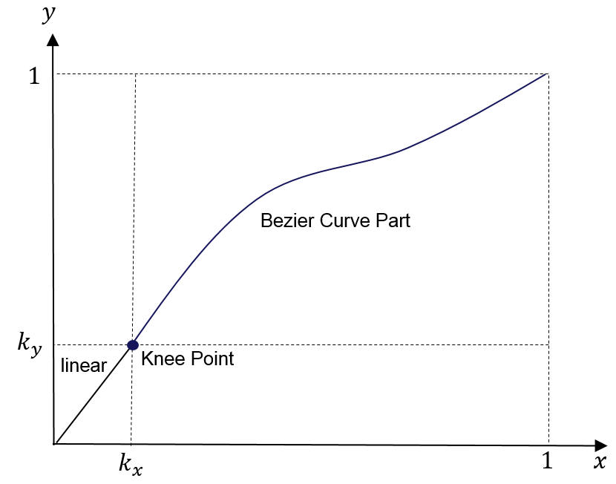
Figure 4.3.1 Example OOTF.
See ST 2094-40 [1] for more information regarding the basis OOTF.

Reference Method for Receiver-side Tone Mapping using ST 2094-40 Metadata

General
Figure 4.3.2 shows a block diagram of a tone mapping function based on 2094-40 metadata.
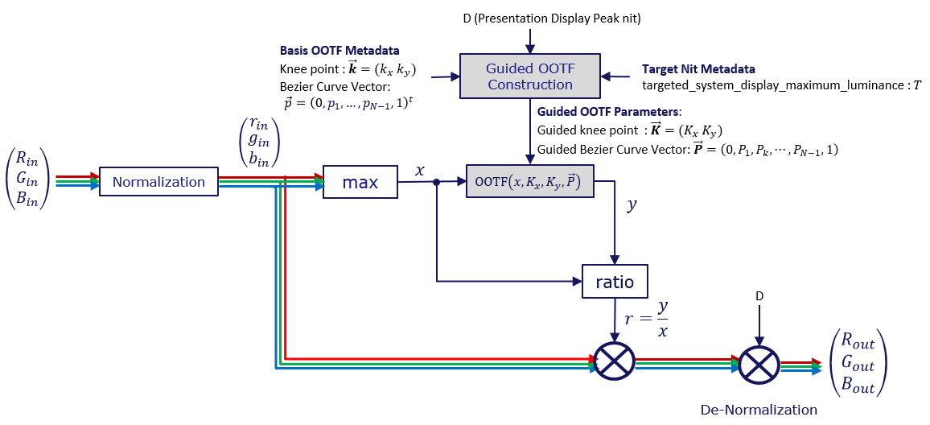
Figure 4.3.2 Tone-mapping system of an SMPTE 2094-40 device.
Normalization is performed as follows:
The linear RGB signals ${\left(R_{in}, G_{in}, B_{in}\right)}^{t}$ fed to the tone mapping system represent absolute luminance, and must be converted to a single channel input $x$ before applying the guided OOTF, which processes a single input parameter.
The absolute luminance values ${\left(R_{in}, G_{in}, B_{in}\right)}^{t}$ are normalized into the values between 0 and 1 by
ringinbin=min1, Rin/NORM min1, Gin/NORM min1, Bin/NORM (1)
where $NORM$ is the normalization factor given by
NORM=max(D, HM) (2)
in which D is the peak luminance of the presentation display and H_{M} = distribution_values[0][8]$.$
For each pixel, the maximum value of r_{in}, g_{in}, and b_{in} is determined, as represented by x. The value of x is applied to the guided OOTF, producing the resultant value, y. The values of r_{in}, g_{in}, and b_{in} are each scaled by the ratio of y/x.
At the end of the process, the signal is de-normalized based on the peak luminance of the presentation display.

Guided OOTF Construction

General
The guided OOTF is based on the peak luminance of the presentation display and is derived from the basis OOTF. There are three cases:
- The peak luminance of the presentation display (D) is equal to the target peak luminance (T), in which case the basis OOTF can be used directly;
- the peak luminance of the presentation display (D) is greater than the target peak luminance (T), in which case the basis OOTF is effectively interpolated with a linear transfer function to create the guided OOTF;
- the peak luminance of the presentation display (D) is less than the target peak luminance (T), in which case the basis OOTF is extrapolated to create the guided OOTF.
In each case, the goals are to create a transfer function appropriate for the presentation display, be reasonably faithful to the nature of the guided OOTF, and to avoid introducing level or slope discontinuities that might introduce visible artifacts.
A reference method of guided OOTF generation is as follows. This method is shown to produce good results; however, it is possible that other implementations can improve the interpolation and extrapolation processes to produce results with improved detail and faithfulness to the intent of the basis OOTF.
In general, guided OOTF construction is composed of the following two parts with the inputs $T$ (peak luminance of the target display that is obtained with the basis OOTF) and $D$ (peak luminance of the presentation display):
- Guided Knee Point
- Guided Bezier Curve Anchors
They are described in the subsequent sections.

Guided Knee Point Construction
The construction of the guided knee point can be classified into two cases.
Case I: When $D≤T$
The guided knee point, $\vec{K}=\left(\begin{aligned}K_{x} \\ K_{y}\end{aligned}\right),$can be obtained by
K=w,1-w∙kK0 (3)
where $∙$ represents the dot product of two vectors, $\vec{k}=\left(\begin{aligned}k_{x} \\ k_{y}\end{aligned}\right)$ is the knee point of the given basis OOTF, ${\vec{K}}_{0}$ is a pre-defined constant vector such as $\left(\begin{aligned}0 \\ 0\end{aligned}\right)$, and $w$ is the guided knee point mixing parameter as a function of $D$. There are various ways to design $w$; however, a linear method is simple and effective. The reference, linear method is as shown in Figure 4.3.3, where $D_{L}$ is a pre-defined low luminance level, where $D_{L}≤T$.
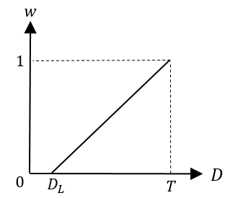
Figure 4.3.3 Example of guided knee point mixing parameter function when $D≤T$.
Figure 4.3.4 shows the graphical illustration of how the guided knee point is constructed as a function of $D$ as expressed in (3), where the dotted red arrow is the Guide Knee Point trajectory.
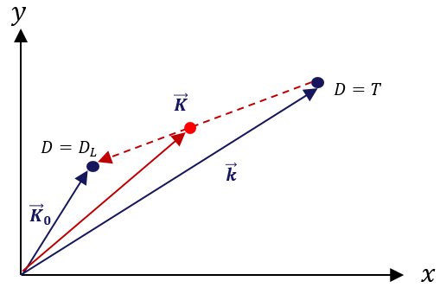
Figure 4.3.4 The guided knee point when $D≤T$.
Case II: When $T≤D$
Similar to $D≤T$, in the case that $T≤D$, the guided knee point , $\vec{K}=\left(\begin{aligned}K_{x} \\ K_{y}\end{aligned}\right)$can be obtained by
K=w,1-w∙kK1 (4)
where ${\vec{K}}_{1}=\left(\begin{aligned}0.5 \\ 0.5\end{aligned}\right),$ and $w$ is the guided knee point mixing parameter as a function of $D$ which can be designed as shown in Figure 4.3.5.
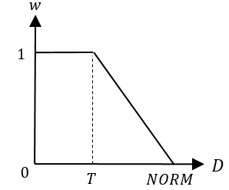
Figure 4.3.5 Example of guided knee point mixing parameter function when $T≤D$.
Figure 4.3.6 shows the graphical illustration of how the guided knee point is constructed as a function of $D$ as expressed in (4), where the dotted red arrow is the guide knee point trajectory.
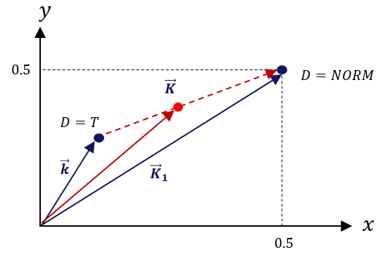
Figure 4.3.6 The guided knee points when $T≤D$.
Note that
K=K1=0.50.5 (5)
when $NORM≤D.$

Guided Bezier Curve Vector Construction
Following two properties of the Bezier curve are fundamental to understand the notion behind the guided Bezier curve vector construction.
Property 1: If
PL=01N⋮N-1N1 (6)
then the normalized explicit Bezier curve becomes an identity line. That is, $B_{N}\left({\vec{P}}_{L}, t\right)=t$ and ${\vec{P}}_{L}$ is referred to as the identity Bezier curve vector.
Property 2: Linearly adding two Bezier curves in the same order is equivalent to linearly adding their Bezier curve vectors. That is, if we let $B_{N}(\vec{α}, t)$ and $B_{N}(\vec{β}, t)$ two Bezier curves in $N^{th}$ order characterized by the Bezier curve vectors $\vec{α}$ and $\vec{β}$, respectively, such as
BNα, t=k=0NCNktk1-tN-k⋅αkBNβ, t=k=0NCNk tk1-tN-k⋅βk , (7)
then the following can be easily shown
a,b∙BN(α, t)BN(β, t)=BNγ,t (8)
where
γ=(a,b)∙αβ (9)
Similar to the guided knee point construction, the guided Bezier curve vector construction from a given basis Bezier curve vector can also be classified into two cases. The basic idea behind guided Bezier curve construction is to interpolate Bezier curve with the Bezier curve of the basis OOTF and a pre-determined boundary Bezier curve as a function of $D.$
Case I: When $D≤T$
In the case of $D≤T,$ the guided Bezier curve, $B_{N}\left(\vec{P}, t\right)$, can be found as
BNP, t=u, 1-u∙BN(p, t)BN(P0, t) (10)
where $\vec{p}=\vec{p}={\left(0, p_{1}, …, p_{N-1}, 1\right)}^{t}$ is the Bezier Curve vector of basis OOTF, and ${\vec{P}}_{0}$ is a pre-defined Bezier curve vector such as, but not limited to, ${\left(1,1,⋯, 1\right)}^{t}$, and $u$ is the control parameter as a function of $D$ which can be designed as shown in Figure 4.3.7 but not limited to.
By Property 2, the guided Bezier curve vector, $\vec{P}$, of $B_{N}\left(\vec{P}, t\right)$can be calculated as
P=u,1-u∙pP0 (11)
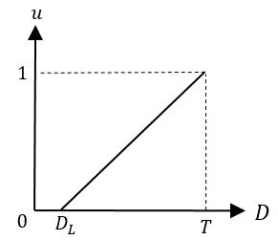
Figure 4.3.7 Example of Bezier curve vector mixing coefficient function for $D≤T$.
Case II: When $T≤D$
In the case of $T≤D,$ the guided Bezier curve, $B_{N}\left(\vec{P}, t\right)$, can be found as
BNP, t=u, 1-u∙BN(p, t)BN(PL, t) (12)
where $\vec{p}=\vec{p}={\left(0, p_{1}, …, p_{N-1}, 1\right)}^{t}$ is the Bezier Curve vector of the basis OOTF, and ${\vec{P}}_{L}$ is Identity Bezier curve introduced in (6), and $u$ is the mixing parameter as a function of $D$ which can be designed as shown in Figure 4.3.8 but not limited to.
By Property 2, the guided Bezier curve vector, $\vec{P}$, of $B_{N}\left(\vec{P}, t\right)$can be calculated as
P=(u,1-u)∙pPL (13)
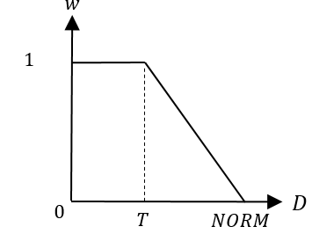
Figure 4.3.8 The Bezier curve anchor control determining function for $T≤D.$
Note that we have
P=PL (14)
when $NORM≤D.$
Note: By merging (5) and (14), the guided OOTF becomes the identity line as depicted in Figure 4.3.9 when $NORM≤D,$ which is the case when the dynamic range of the presentation display is larger than that of the incoming HDR scene.
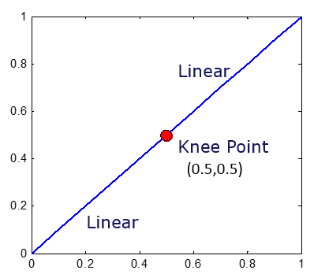
Figure 4.3.9 The guided Bezier curve when $NORM≤D$.

Slope Continuity Condition at the Knee Point
After the guided Knee point and Bezier curve vector are constructed, one last step is required to adjust the Bezier curve vector to ensure the slope continuity at the guided knee point. Note that the linear part and the Bezier curve part of a guided OOTF curve are jointed by the knee point. Discontinuity between the two parts at the knee point may lead to banding artifacts in the tone-mapped signal. In any implementations of the SMPTE 2094-40 TM system, the condition for continuity of the slopes at the knee point must be satisfied. Namely, the tangent of the Bezier curve part at the knee point should be equal to the slope of the linear part, which can be expressed as
ddxKy+1-Ky⋅BNP,x-Kx 1-Kxx=Kx=KyKx (15)
By solving (15), the condition for continuity of the slopes at the knee point is given as
P1=1N⋅KyKx⋅1-Kx1-Ky (16)
Figure 4.3.10 shows some examples of various guided OOTF curves that satisfy the condition for continuity of the slopes at the knee point. As can be seen in Figure 4.3.10, the OOTF curves are continuous and will not lead to banding artifacts.
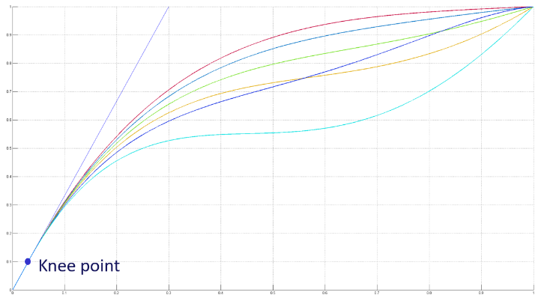
Figure 4.3.10 Examples of the continuity of different guided OOTF curves at the knee point.

Statistical Characteristics
Statistical measurements of each video picture is a straightforward mathematical process that is performed before emission. See ST 2094-40 [1] for details.
While it is possible for a receiver to make these same measurements on a frame-by-frame basis, it is more efficient to perform this process upstream. These video picture-based measurements cannot be completed until the full picture is available, potentially requiring frame buffers if calculated in the receiver. However, when measured before the emission, the calculations do not necessarily add latency. For instance, the measurement can be calculated in parallel with HEVC encoding, which necessarily adds latency of more than one picture of video, and the metadata is then inserted after encoding is completed. In addition, the receiver would not be able to make forward-looking, scene-based measurements.
Television sets, even with extremely high peak luminance capabilities, do not necessarily employ a neutral transfer function. The user might have selected a picture preset (Dynamic Mode) with high contrast based on personal preferences. An ambient light sensor might indicate a very bright environment, in which case low- and mid-tones might be lifted in order to ensure that the image is clearly visible. The manufacturer might also employ an adjustment to compensate for characteristics of the physical display device.
The statistical characteristic metadata can aid the television set in making the above adjustments. In general, a good implementation would avoid compressing the dynamic range in signal ranges where there is high information density and would instead compress the dynamic range in signal ranges with low information density. How this is achieved is left to the manufacturer and is not specified in this document.
End of Document

