Advanced Television Systems Committee
1300 I Street, N.W, Suite 400E
Washington, D.C. 20005
202-872-9160
Doc. A/345:2024-03
28 March 2024
ATSC Candidate Standard:
VVC Video
The Advanced Television Systems Committee, Inc. is an international, non-profit organization developing voluntary standards and recommended practices for broadcast television and multimedia data distribution. ATSC member organizations represent the broadcast, professional equipment, motion picture, consumer electronics, computer, cable, satellite, and semiconductor industries. ATSC also develops implementation strategies and supports educational activities on ATSC standards. ATSC was formed in 1983 by the member organizations of the Joint Committee on Inter-society Coordination (JCIC): the Consumer Technology Association (CTA), the Institute of Electrical and Electronics Engineers (IEEE), the National Association of Broadcasters (NAB), the Internet & Television Association (NCTA), and the Society of Motion Picture and Television Engineers (SMPTE). For more information visit www.atsc.org.
Note: The user’s attention is called to the possibility that compliance with this standard may require use of an invention covered by patent rights. By publication of this standard, no position is taken with respect to the validity of this claim or of any patent rights in connection therewith. One or more patent holders have, however, filed a statement regarding the terms on which such patent holder(s) may be willing to grant a license under these rights to individuals or entities desiring to obtain such a license. Details may be obtained from the ATSC Secretary and the patent holder.
Implementers with feedback, comments, or potential bug reports relating to this document may contact ATSC at https://www.atsc.org/feedback/.
Revision History
Version | Date
Candidate Standard approved | 16 November 2023
CS update approved | 28 March 2024
Standard approved | Insert date here

Table of Contents
1. SCOPE 5
1.1 Overview 5
1.2 Introduction and Background 5
1.3 Organization 5
2. References 5
2.1 Normative References 5
2.2 Informative References 6
3. Definition of Terms 7
3.1 Compliance Notation 7
3.2 Treatment of Syntactic Elements 8
3.2.1 Reserved Elements 8
3.3 Acronyms and Abbreviations 8
3.4 Terms 9
3.5 Extensibility 9
4. System Overview 9
4.1 Features 9
4.2 System Architecture 10
5. VVC for use in ATSC 3.0 10
5.1 Media Profiles 10
5.1.1 Constrained Baseline VVC 10
5.1.2 Full Range Constrained Baseline VVC 10
5.1.3 Multilayer VVC 11
5.2 Constraints 11
5.2.1 General Constraints 11
5.2.2 Transfer Characteristics 12
5.2.3 Carriage of Active Format Description (AFD) and Bar Data 12
5.2.4 AFD and Bar Data 12
5.2.5 Standard Dynamic Range 12
5.2.6 High Dynamic Range, PQ Transfer Characteristics 14
5.2.7 High Dynamic Range, HLG Transfer Characteristics 16
5.3 Multilayer Constraints 17
5.3.1 Multilayer-Specific Constraints 17
5.3.2 SL-HDR1 Usage with Multilayer VVC 17
5.3.3 Specific Constraints Regarding 3D 18
Annex A : Resolution and Frame Rate Considerations 19
Annex B : Realistic UHD-VVC 3D Service System (Informative) 20
B.1 service scenario 20
B.1.1 Overview 20
B.1.2 Over-the-Air (OTA) 20
B.1.3 Over-the-Top (OTT) 22
B.2 HMD Application 23
B.3 Video Enhancement Information 23

Index of Figures and Tables
Figure B.1 Example of UHD-VVC 3D Service Scenario. 20
Figure B.2 ATSC3.0 VVC-3D OTA Service Delivery. 21
Figure B.3 Example configuration of a mobile HD right view and a fixed UHD left view
using Multilayer VVC. 22
Figure B.4 ATSC 3.0 VVC-3D Broadband (OTT) Service Delivery. 22
Figure B.5 Example configuration of HMD using Multilayer VVC. 23

Table 5.1 CMAF Media Profiles 10
Table 5.2 user_data_type_code 15
Table 5.3 Multiview View Position SEI Message 18

ATSC Candidate Standard:
VVC Video

SCOPE

Overview
This Standard describes the video coding constraints on ITU-T Rec. H.266 | International Standard ISO/IEC 23090-3 [3] (“VVC”) when it is used for video compression in the ATSC 3.0 Digital Television System.
Any other video coding technologies in the ATSC 3.0 system are documented in their own ATSC Standard(s). ATSC A/300 [11] provides references to the various video coding technology document(s) in the ATSC 3.0 system. Signaling of the video compression technology in use is defined in ATSC A/331 [12].

Introduction and Background
This Standard specifies VVC-coded video when it is used in the ATSC 3.0 Digital Television System. It specifies the use of VVC, including features such as Spatial Scalable Coding, High Dynamic Range, Wide Color Gamut, and 3D.
AFD and Bar Data are defined such that the Active Area of the picture does not necessarily need to fill the entire coded area. (See Sections 5.2.3 and 5.2.4.)

Organization
This document is organized as follows:
- Section 1 – Outlines the scope of this document and provides a general introduction.
- Section 2 – Lists references and applicable documents.
- Section 3 – Provides a definition of terms, acronyms, and abbreviations for this document.
- Section 4 – System overview.
- Section 5– Specification of Profiles and constraints of VVC for use in ATSC 3.0.
- Annex A – Resolution and frame rate considerations.
- Annex B – 3D Service System.
Section 5.1 describes three Media Profiles: Constrained Baseline VVC, Full Range Constrained Baseline VVC, and Constrained Multilayer VVC. Section 5.2 specifies constraints that apply to all of the Media Profiles. Section 5.3 specifies Multilayer Constraints that apply to the Constrained Multilayer VVC Media Profile.

References
All referenced documents are subject to revision. Users of this Standard are cautioned that newer editions might or might not be compatible.

Normative References
The following documents, in whole or in part, as referenced in this document, contain specific provisions that are to be followed strictly in order to implement a provision of this Standard.
- IEEE: “Use of the International Systems of Units (SI): The Modern Metric System,” Doc. SI 10, Institute of Electrical and Electronics Engineers, New York, N.Y.
- ISO/IEC: 23000-19:2022, “Information technology — Multimedia application format (MPEG-A) — Part 19: Common media application format (CMAF) for segmented media,” Doc. 23000-19, ISO/IEC, Geneva, Switzerland.
- ISO/IEC: 23090-3:2023 | Rec. ITU-T H.266 (9/2023), “Information technology — Coded representation of immersive media — Part 3: Versatile Video Coding,” Geneva, Switzerland.
- ISO/IEC: 23002-7:2023 | Rec. ITU-T H.274 (9/2023), “Information technology — MPEG video technologies — Part 7: Versatile supplemental enhancement information messages for coded video bitstreams,” Geneva, Switzerland.
- ETSI: “High-Performance Single Layer High Dynamic Range (HDR) System for use in Consumer Electronics devices; Part 1: Directly Standard Dynamic Range (SDR) Compatible HDR System (SL-HDR1)”, Doc. ETSI TS 103 433-1 V1.4.1 (2021-08), European Telecommunications Standards Institute, Sophia Antipolis Cedex, France.
- ETSI: “HDR Signalling and Carriage of Dynamic Metadata for Colour Volume Transform; Application #1”, Doc. ETSI TS 103 572 V1.3.1 (2021-08), European Telecommunications Standards Institute, Sophia Antipolis Cedex, France.
- SCTE: “AVC Video Constraints For Cable Television Part 1- Coding” Doc. ANSI/SCTE 128-1 2020, Society of Cable Telecommunications Engineers, Exton, PA.
- SMPTE: “Dynamic Metadata for Color Volume Transformation – Application #4,” Doc. ST 2094-40:2020, Society of Motion Picture and Television Engineers, White Plains, NY.
- CTA: “A DTV Profile for Uncompressed High Speed Digital Interfaces,” Doc. CTA-861-H (December 2020), Consumer Technology Association, Arlington, VA.
- ATSC: “3D-TV Terrestrial Broadcasting, Part 5 – Service Compatible 3D-TV using Main and Mobile Hybrid Delivery,” Doc. A/104 Part 5:2015-10, Advanced Television Systems Committee, Washington, DC, 28 October 2015.

Informative References
The following documents contain information that may be helpful in applying this Standard.
- ATSC: “ATSC Standard: ATSC 3.0 System,” Doc. A/300:2023-03, Advanced Television Systems Committee, Washington, DC, 28 March 2023.
- ATSC: “ATSC Standard: Signaling, Delivery, Synchronization, and Error Protection,” Doc. A/331:2023-12, Advanced Television Systems Committee, Washington, DC, 13 December 2023.
- ATSC: “ATSC Standard: Video – HEVC,” Doc. A/341:2023-03, Advanced Television Systems Committee, Washington, DC, 28 March 2023.
- ITU: ITU-R Recommendation BT.709-6 (06/2015), “Parameter values for the HDTV standards for production and international programme exchange,” International Telecommunications Union, Geneva.
- ITU: ITU-R Recommendation BT.2020-2 (2015), “Parameter values for ultra-high definition television systems for production and international programme exchange,” International Telecommunications Union, Geneva.
- ITU: “Image parameter values for high dynamic range television systems for use in production and international programme exchange,” Doc. Recommendation ITU-R BT.2100-2 (07/2018), International Telecommunications Union, Geneva.
- SMPTE: “Mastering Display Color Volume Metadata for High Luminance and Wide Color Gamut Images,” Doc. ST 2086 (2014), Society of Motion Picture and Television Engineers, White Plains, NY.
- SMPTE: “Dynamic Metadata for Color Volume Transformation – Application #1,” Doc. ST 2094-10 (2016), Society of Motion Picture and Television Engineers, White Plains, NY.
- ITU: ITU-R Recommendation BT.2390-11 (03/2023), “High dynamic range television for production and international programme exchange,”, International Telecommunications Union, Geneva.
- SMPTE: “Dynamic Metadata for Color Volume Transformation – Core Components,” Doc. ST 2094-1 (2016), Society of Motion Picture and Television Engineers, White Plains, NY.
- SCTE: “HEVC Video Constraints for Cable Television Part 1-1 HDR,” Doc. SCTE 215-1-1 2020b, Society of Cable Telecommunications Engineers, Inc., Exton, PA.
- Higher Frame Rates for More Immersive Video and Television, BBC, http://downloads.bbc.co.uk/rd/pubs/whp/whp-pdf-files/WHP209.pdf
- SMPTE: “Format for Active Format Description and Bar Data,” Doc. ST 2016-1 (2019), Society of Motion Picture and Television Engineers, White Plains, NY.
- ETSI: “Digital Video Broadcasting (DVB); Specification for the use of Video and Audio Coding in Broadcasting Applications based on the MPEG-2 Transport Stream”, Doc. ETSI TS 101 154 V2.8.1 (2023-07), European Telecommunications Standards Institute, Sophia Antipolis Cedex, France.
- CTA: “Active Format Description (AFD) & Bar Data Recommended Practice,” Doc. CTA-CEB16-B R-2022 (July 2017), Consumer Technology Association, Arlington, VA.
- ISO/IEC: TR 23091-4:2021 | ITU-T Series H.Suppl.19 (4/2021), “Information technology — Coding-independent code points — Part 4: Usage of video signal type code points,” Geneva, Switzerland.
- SMPTE: “Interoperable Master Format – Application #2E,” Doc. ST 2067-21:2016, Society of Motion Picture and Television Engineers, White Plains, NY.
- SCTE: “VVC Coding Constraints,” Doc: SCTE 281-1:2023, Society of Cable Telecommunications Engineers, Inc., Exton, PA.

Definition of Terms
With respect to definition of terms, abbreviations, and units, the practice of the Institute of Electrical and Electronics Engineers (IEEE) as outlined in the Institute’s published standards [1] shall be used. Where an abbreviation is not covered by IEEE practice or industry practice differs from IEEE practice, the abbreviation in question will be described in Section 3.3 of this document.

Compliance Notation
This section defines compliance terms for use by this document:
shall – This word indicates specific provisions that are to be followed strictly (no deviation is permitted).
shall not – This phrase indicates specific provisions that are absolutely prohibited.
should – This word indicates that a certain course of action is preferred but not necessarily required.
should not – This phrase means a certain possibility or course of action is undesirable but not prohibited.

Treatment of Syntactic Elements
This document contains symbolic references to syntactic elements used in the audio, video, and transport coding subsystems. These references are typographically distinguished by the use of a different font (e.g., restricted), may contain the underscore character (e.g., sequence_end_code) and may consist of character strings that are not English words (e.g., dynrng).

Reserved Elements
One or more reserved bits, symbols, fields, or ranges of values (i.e., elements) may be present in this document. These are used primarily to enable adding new values to a syntactical structure without altering its syntax or causing a problem with backwards compatibility, but they also can be used for other reasons.
The ATSC default value for reserved bits is ‘1.’ There is no default value for other reserved elements. Use of reserved elements except as defined in ATSC Standards or by an industry standards-setting body is not permitted. See individual element semantics for mandatory settings and any additional use constraints. As currently reserved elements may be assigned values and meanings in future versions of this Standard, receiving devices built to this version are expected to ignore all values appearing in currently reserved elements to avoid possible future failure to function as intended.

Acronyms and Abbreviations
The following acronyms and abbreviations are used within this document.
3D – Three dimensional
AFD – Active Format Description
ATSC – Advanced Television Systems Committee
BBC – British Broadcasting Corporation
CMAF – Common Media Application Framework
ETSI – European Telecommunications Standards Institute
fps – frames (or pictures) per second
HD – High Definition
HDR – High Dynamic Range
HEVC – High Efficiency Video Coding
HLG – Hybrid Log-Gamma
HMD – Head Mounted Display
HTTP – Hypertext Transfer Protocol
Hz – Hertz
IP – Internet Protocol
IRAP – Intra Random Access Point
MDCV – Mastering Display Color Volume
MPEG – Motion Picture Experts Group
MVPD – Multichannel Video Programming Distributor
NAL – Network Abstraction Layer
OTA – Over The Air
OTT – Over The Top
PLP – Physical Layer Pipe
PQ – Perceptual Quantization
SCTE – Society of Cable Telecommunications Engineers
SD – Standard Definition
SDR – Standard Dynamic Range
SEI – Supplemental Enhancement Information
SL-HDR1 – Single Layer High Dynamic Range part 1
SPS – Sequence Parameter Set
TCP – Transmission Control Protocol
UHD – Ultra High Definition
UHDTV – Ultra High Definition Television
VEI – Video Enhancement Information
VPS – Video Parameter Set
VSEI - Versatile Supplemental Enhancement Information
VVC – Versatile Video Coding

Terms
The following terms are used within this document.
Active Area – The portion of the video picture area that is being utilized for program content.
Additional View – A Stereoscopic 3D video component using equivalent or lower resolution compared to the Reference View video.
Bar Data –Data that enables computation of regions of the image that are outside of the Active Area. See CTA-CEB16 [25].
DM App #1 – Dynamic metadata system also known as ST 2094-10 [18].
DM App #4 – Dynamic metadata system also known as ST 2094-40 [8].
High Dynamic Range – A feature that allows representation of video levels with much higher luminance values than is possible with traditional video methods. (See Section 5.2.2.)
Level – A defined set of constraints on the values that may be taken by the syntax elements and variables of the VVC specification [3].
Profile – A specified subset of the syntax of the VVC specification [3].
Spatial Scalable Coding – A method of providing low and high spatial resolution versions of content through use of a base and an enhancement layer.
Reference View – A Stereoscopic 3D video component with the spatial resolution equal to or greater than the Additional View.
reserved – Set aside for future use by a Standard.
Tier – A specified category of Level constraints imposed on values of the syntax elements in the bitstream. See the VVC specification [3] for details.
Wide Color Gamut – A feature that allows representation of chrominance levels with much broader range than is possible with BT.709 [14].

Extensibility
This Standard includes no known extensibility mechanisms of unknown compatibility.

System Overview

Features
This Standard describes constraints and optional capabilities of ISO/IEC: 23090-3:2022 “VVC” [3] when used in the ATSC 3.0 system. Key features include:
- VVC Main 10 Profile, aligned with MPEG CMAF, with additional constraints
- VVC Levels up to 6.1 supported, enabling Ultra HD (4K up to 120fps, 8K up to 60fps)
- Optional High Dynamic Range (HDR) support, including PQ, HLG, static HDR metadata, and dynamic HDR metadata solutions DM App #1, DM App #4 and SL-HDR1
- Optional Spatial Scalability based on the Multilayer VVC Media Profile and aligned with CMAF
- Optional use of AFD and Bar Data, enabling aspect ratios other than 16:9 and including 9:16 "portrait mode”
- Optional use of full range video

System Architecture
VVC video stream data is encapsulated in transport as specified in ATSC A/331 [12], with signaling as specified in the same Standard. VVC, like its predecessors AVC and HEVC [13], is based on a Network Abstraction Layer (“NAL”) Unit encapsulation approach, as documented in the VVC standard [3].

VVC for use in ATSC 3.0

Media Profiles
This section defines various VVC CMAF Media Profiles based on ISO/IEC 23000-19 [2], Annex M, which are summarized in Table 5.1.
Table 5.1 CMAF Media Profiles
Media Profile Name | Profile Brand | Section
Constrained Baseline VVC | ‘cvvc’ | 5.1.1
Full Range Constrained Baseline VVC | ‘cafr’ | 5.1.2
Constrained Multilayer VVC | ‘cvvm’ | 5.1.3

Constrained Baseline VVC
This Media Profile shall comply with the Baseline VVC Media Profile as defined in 23000-19 [2], Annex M.2, “Baseline VVC Media Profile”, as further constrained Section 5.2
Note that the Baseline VVC Media Profile constrains the Tier to Main tier and the Profile to Main 10. Note that when a bitstream is indicated to conform to a Level that is lower than Level 6.1, it is also considered as conforming to Level 6.1.

Full Range Constrained Baseline VVC
This Media Profile shall comply with the Constrained Baseline VVC Media Profile as defined in Section 5.1.1 as further extended in this section.
- Each SPS shall have vui_full_range_flag present and set equal to 0 or 1.
- Each SPS shall have matrix_coeffs present and set equal to 9 or 14. This constrains the matrix coefficients to non-constant luminance Y′C_{B}C_{R} or constant intensity IC_{T}C_{P}, respectively, as defined in ITU-R BT.2100 [16]. Note that switching between these modes during a transmission could lead to a disturbance in downstream retransmission systems and consumer devices.
- When matrix_coeffs is set to 14, vui_full_range_flag shall be set to 1.

Multilayer VVC
This Media Profile shall comply with the Multilayer VVC Media Profile as defined in 23000-19 [2], Annex M.3, “Multilayer VVC Media Profile”, as further constrained in Sections 5.2 and 5.3. Both the base layer and enhancement layer shall comply with the constraints of Section 5.2.

Constraints

General Constraints
This Media Profile shall comply with the Baseline VVC Media Profile as defined in 23000-19 [2], Annex M.2, “Baseline VVC Media Profile”, as further constrained in this section. Note that the Baseline VVC Media Profile constrains the Tier to Main tier and the Profile to Main 10. Note that when a bitstream is indicated to conform to a Level that is lower than Level 6.1, it is also considered as conforming to Level 6.1. For guidance on other general operational VVC video parameter configurations not specifically called out in this section, SCTE 281-1 [28] is an additional informational source.
- The Level shall be constrained to 6.1.
- The spatial resolution shall be constrained to not more than 4320 lines and 7680 horizontal pixels.
- For spatial resolutions of 2160 lines or fewer and 3840 horizontal pixels or fewer, the spatial resolution in both dimensions shall be evenly divisible by 8.
- For spatial resolutions of more than 2160 lines or more than 3840 horizontal pixels, the spatial resolution in both dimensions shall be evenly divisible by 32.
- The picture rate in 60 Hz regions shall be one of the following in Hz: 24/1.001, 24, 30/1.001, 30, 60/1.001, 60, 120/1.001, 120.
- The picture rate in 50 Hz regions shall be one of the following in Hz: 25, 50, 100.
- The scan shall be progressive.
- The pixel aspect ratio shall be 1:1 (square pixels).
- The aspect ratio of each picture shall be 16:9 or 9:16. Note that other aspect ratios can be supported with the use of AFD and Bar Data as described in Section 5.2.4.
- Coded representation of video with 1080 lines (e.g., 1920x1080) may be coded either as 1080 lines or as 1088 lines. When the video is coded as 1088 lines, the bottom 8 lines shall be black.
- When 960x540 is emitted, it shall be coded as 960x544, and the bottom four lines shall be black.
- Each SPS shall have sps_bitdepth minus8 set equal to 2. This constrains the bit depth to 10 bits.
- Each SPS shall have sps_vui_parameters_present_flag set equal to 1. This indicates that the vui_parameters() syntax structure as specified in VVC [3] Section 7.3.2.4 is present.

- In the case of non-full range, Y′C_{B}C colorimetry, each SPS shall have vui_matrix_coeffs present and set equal to 9. This constrains the matrix coefficients to non-constant luminance Y′C_{B}C_{R}, as defined in ITU-R BT.2100 [16].

Regarding format switching, the following constraint shall apply.
- The time interval between consecutive changes in general_level_idc shall be greater than or equal to five seconds.
If such seamless or near-seamless behavior in the VVC receiver is desired, it is highly recommended that parameters such as general_level_idc, the vertical picture size, and colorimetry information in the VVC elementary stream should not change. Profile changes, Level changes, display aspect ratio changes, frame rate changes, and colorimetry changes should be avoided as they might result in disruption of the decoder's video output and might cause non-seamless output behavior in receivers.

Transfer Characteristics
The video transfer characteristics shall be signaled as one of the following: SDR, PQ, or HLG as specified in Sections 5.2.5, 5.2.6, and 5.2.7, respectively.
Note that switching between these transfer characteristics during a transmission could lead to a disturbance in downstream retransmission systems and consumer devices.
Conversions between different transfer characteristics may be necessary for broadcast emission and/or MVPD retransmission to allow the transfer function and color space to remain constant within or among services or for other purposes; some of these conversions will need to be made in real-time. Report ITU-R BT.2390 [18] contains information on conversions between HDR transfer characteristics and associated constraints and compromises.

Carriage of Active Format Description (AFD) and Bar Data
AFD and Bar Data, when present, shall be carried according to ANSI/SCTE 128-1 [7], Section 8.1 as further constrained and described in Section 5.2.4 of this document.
Note: Additional background on AFD and Bar Data may be found in SMPTE ST 2016-1 [23], ETSI TS 101 154 V2.1.1 [24], and CTA-CEB16 [25].

AFD and Bar Data
AFD and Bar Data shall be as specified by ANSI/SCTE 128-1 [7], Section 8.2.7.
Note: The Display Aspect Ratio in Table 6.1, Table 6.2, and Table B.1.1 of [7] refers to the aspect ratio of the active image area before AFD and Bar Data are applied. Display devices can use AFD and Bar Data to crop and/or expand the picture that is displayed to the user. For example, a service including video encoded at a resolution of 3840x2160 may have AFD and Bar Data that indicates that the active image area is contained within a 3840x1620 rectangle.
Note: SMPTE 2016-1 [23] does not include Ultra HD resolutions at this time and is in the process of being updated.

Standard Dynamic Range

SDR Constraints
For video with SDR transfer characteristics, the following constraints apply:
- Each SPS shall have colour_description_present_flag set equal to 1. This indicates that the colour_primaries, transfer_characteristics, and matrix_coeffs elements are present.
- Each SPS shall have colour_primaries present and set equal to either 1 or 9. This constrains the color primaries to be ITU-R BT.709 [14] or ITU-R BT.2020 [15], respectively.
- Each SPS shall have vui_chroma_loc_info_present_flag set equal to 1 and vui_chroma_sample_loc_type_frame set equal to 0. Note that VVC Main 10 profile constrains the color subsampling to 4:2:0. See H.274 [4] Figure 4 for more information.
- Each SPS shall have transfer_characteristics present and set equal to 1. This constrains the transfer characteristics to SDR as specified by ITU-R BT.709 [14].
- Each SPS shall have matrix_coeffs present and set equal to either 1 or 9 and the value shall be identical to the value of colour_primaries. This constrains the matrix coefficients to be ITU-R BT.709 [14], or ITU-R BT.2020 [15] with non-constant luminance, respectively.
- The colour_mapping_enabled_flag shall be set to 0.
- Video with SDR transfer characteristics may contain SL-HDR1 Metadata as documented in Section 5.2.5.2.

MDCV for SDR
When available, tThe bitstream should contain SEI messages with MDCV payloadType value equal to 137, for SDR streams. These messages correspond to Mastering Display Color Volume. They shall conform to the construction described in VSEI [4]. When MDCV SEI message(s) are present on input, they should also be included and passed through, unchanged in the emitted bitstream.
Examples of MDCV for SDR are available in ITU-T Series H Supplement 19 [26].

SL-HDR1 Metadata
SL-HDR1 Metadata messages are an aggregation of parameters, syntactically and semantically specified in ETSI TS 103 433-1 [5], Section 6, which may be used in the decoding process to reconstruct HDR video from an SDR encoded video stream.
A VVC video stream may contain SL-HDR1 Metadata in order to provide both an SDR picture and an HDR picture from the same video stream. When SL-HDR1 Metadata messages are present, they allow reconstructing the HDR video from the received SDR video stream. The reconstructed HDR video can be represented as linear light or using any of the available HDR transfer functions listed in these specifications.
Usage of SL-HDR1 Metadata is as follows. At the emission encoder, HDR video is decomposed into SDR video (“derived SDR”) and associated SL-HDR1 Metadata. The SDR video and accompanying SL-HDR1 Metadata are encoded in a VVC stream.
When present, SL-HDR1 Metadata parameters shall be encapsulated into an SEI message, named SL-HDR Information SEI message, as specified in ETSI TS 103 433-1 [5]. Mapping SL-HDR Information SEI message syntax elements to SL-HDR1 Metadata is documented in ETSI TS 103 433-1 [5], Section A.2.3.
The following references document the non-normative SL-HDR1 decomposition process:
- Annex C of ETSI TS 103 433-1 [5] provides HDR-to-SDR decomposition principles that may be used to generate the derived SDR video prior to encoding.
- Section D.3 of ETSI TS 103 433-1 [5] provides the forward gamut mapping process that may be used to map the color gamut of the original HDR video (e.g., Rec. BT.2020 [15]) onto the target color gamut of the derived SDR video (e.g., Rec. BT.709 [14]). The forward gamut mapping process is not used when the HDR video gamut and the derived SDR video gamut are the same.
The following references document the normative SL-HDR1 reconstruction process for devices that support SL-HDR1:
- The SDR-to-HDR reconstruction process is specified in Section 7 of ETSI TS 103 433-1 [5].
- When Gamut Mapping is employed at the encoder and signaled in the SL-HDR Information SEI message, the inverse gamut mapping process to map the color gamut of the derived SDR video (e.g., Rec. BT.709 [14]) back to the color gamut of the original HDR video (e.g., Rec. BT.2020 [15]) is specified in Section D.4 of ETSI TS 103 433-1 [5].
If an SL-HDR Information SEI message is present, the following restrictions shall apply:
- It shall be transmitted at least with every IRAP.
- nal_unit_type shall be set to PREFIX_SEI_NUT.
Note: This indicates that the SL-HDR Information SEI message is a prefix SEI NAL unit.
- sl_hdr_payload_mode shall be set to 0.
Note: This constrains the payload carriage mode to the parameter-based mode.
- src_mdcv_info_present_flag value shall be set to 1.
Note: This indicates that mastering display color volume primaries, white point and minimum and maximum luminance are present within the SL-HDR Information SEI message.
- When present, gamut_mapping_mode value shall be set to 1, 2 or 3. See ETSI TS 103 433-1 [5], Section A.2.2.4.

High Dynamic Range, PQ Transfer Characteristics

HDR, PQ Constraints
For HDR video with the PQ transfer characteristics, the following constraints apply:
- Each SPS shall have vui_colour_description_present_flag set equal to 1. This indicates that the colour_primaries, transfer_characteristics, and matrix_coeffs elements are present.
- Each SPS shall have colour_primaries present and set equal to 9. This constrains the color primaries to ITU-R BT.2100 [16].
- Each SPS shall have vui_chroma_loc_info_present_flag set equal to 1 and vui_chroma_sample_loc_type_frame set equal to 2. Note that VVC Main 10 profile constrains the color subsampling to 4:2:0. See H.274 [4] Figure 4 for more information.
- Each SPS shall have transfer_characteristics present and set equal to 16. This constrains the transfer characteristics to Table 4 (PQ System Reference Non-Linear Transfer Functions) of ITU-R BT.2100 [16].
- Each SPS shall have vui_full_range_flag [4] set equal to 0.
- The bitstream shall contain SEI messages with payloadType value equal to 137. This allows for the transmission of the Mastering Display Color Volume SEI message. These messages shall conform to the construction described in the VSEI standard [4].
- The bitstream may contain SEI messages with payloadType value equal to 144. This allows for the optional transmission of the Content Light Level Information SEI message. These messages shall conform to the construction described in the VSEI standard [4].
- The bitstream may contain HDR SEI messages with payloadType value equal to 4. This allows for the optional transmission of the DM App #1 (formerly known as ST 2094-10) metadata message described in Section 5.2.6.2 and the DM App #4 (formerly known as ST 2094-40) metadata message described in Section 5.2.6.3.
For more information regarding Mastering Display Color Volume metadata see SMPTE ST 2086 [17] and ST 2067-21 [27]. For more information regarding Content Light Level Information metadata (MaxFALL and MaxCLL) see CTA-861-H [9] Annex P.

Encoding and Transport of DM App #1 Metadata Messages
The video bitstream may contain the DM App #1 metadata message in order to provide dynamic information about the HDR video signal. When a DM App #1 metadata message is present, this information can be employed by the display to adapt the delivered HDR imagery to the capability of the display device. Furthermore, this metadata can be used to derive an SDR (ITU-R BT.709 [14]) picture by receiving devices such as an ATSC 3.0 receiver/converter. The information conveyed in the DM App #1 metadata message defined in ETSI TS 103 572 [6], Section 4 provides carriage for metadata elements defined in ST 2094-1 [20] and ST 2094-10 [18].
DM App #1 metadata, when present, shall be encoded and transported as User data registered by a Recommendation ITU-T T.35 Supplemental Enhancement Information (SEI) message per the ATSC1_data() structure defined in Table 14 of ANSI/SCTE 128-1 [7] and the assigned value for user_data_type_code is shown in Table 5.2.
Table 5.2 user_data_type_code
user_data_type_code |  | user_data_type_structure
0x09 |  | ST2094-10_data()
The syntax and semantics for payload ST2094-10_data() shall be as specified in ETSI TS 103 572 [6], Section 4.
If a DM App #1 metadata message is present, the following constraints shall apply:
- Where present the corresponding NAL unit type shall be set equal to PREFIX_SEI_NUT.
- The DM App #1 metadata message shall be associated with every access unit of the bitstream. If this message is present, it shall only be present once per access unit.
- app_version shall be set equal to 0.
- The number of extension blocks with ext_block_level equal to 1 shall be constrained to be equal to 1.
- The number of extension blocks with ext_block_level equal to 2 shall be constrained to be less than or equal to 16.
- The number of extension blocks with ext_block_level equal to 4 shall be constrained to be equal 0 or 1.
- The number of extension blocks with ext_block_level equal to 5 shall be constrained to be equal to 0 or 1.

Encoding and Transport of DM App #4 Metadata Messages
The video bitstream may contain DM App #4 metadata messages that provide for carriage of metadata elements defined in SMPTE ST 2094-1 [20] and SMPTE ST 2094-40 [8]. DM App #4 metadata messages, when present, provide descriptive statistical information and other information that can guide tone mapping in displays, frame by frame.
DM App #4 metadata, when present, shall be encoded and transported as User data registered by a Recommendation ITU-T T.35 Supplemental Enhancement Information (SEI) message per CTA-861-H [9] Annex S. The additional constraints specified in CTA-861.H [9] Annex S.4 shall apply. The syntax and semantics of the message are specified in CTA-861-H [9] Annex S.2 and Annex S.3, respectively.
When ST 2094-40 [8] metadata messages are present, the following shall apply:
- The corresponding NAL unit type shall be set equal to PREFIX_SEI_NUT.
- One such message shall be associated with every access unit of the bitstream. If this message is present, it shall only be present once per access unit.
For information about the theory of operation for DM App #4 metadata, see ATSC A/341 [13], Annex F. Note that ATSC A/341 refers to DM App #4 Metadata as metadata based on SMPTE ST 2094-40 [8].
SCTE 215-1-1 [21] defines an HEVC CMAF Media Profile that includes the carriage of DM App #4 dynamic metadata.

High Dynamic Range, HLG Transfer Characteristics
For HDR video with the HLG transfer characteristics, the following constraints apply:
- Each SPS shall have colour_description_present_flag set equal to 1. This indicates that the colour_primaries, transfer_characteristics, and matrix_coeffs elements are present.
- Each SPS shall have colour_primaries present and set equal to 9. This constrains the color primaries to ITU-R BT.2100 [16].
- Each SPS shall have vui_chroma_loc_info_present_flag set equal to 1 and vui_chroma_sample_loc_type_frame set equal to 2. Note that VVC Main 10 profile constrains the color subsampling to 4:2:0. See H.274 [4] Figure 4 for more information.
- Each SPS shall have transfer_characteristics present and set equal to 18. This constrains the transfer characteristics to HLG as specified by Table 5 (Hybrid Log-Gamma (HLG) System Reference Non-Linear Transfer Functions) of ITU-R BT.2100 [16].
- Each SPS shall have vui_colour_description_present_flag set equal to 1 and videovui_full_range_flag [4] set equal to 0. This constrains the sample values to be of narrow range. For more information regarding signal representation, see ITU-R BT.2100 [16], Table 9. Note that “narrow range” is sometimes referred to as “limited range.”

Coded representation of video with 1080 lines (e.g., 1920x1080) may be coded either as 1080 lines or as 1088 lines. When the video is coded as 1088 lines, the bottom 8 lines shall be black.
When 960x540 is emitted, it shall be coded as 960x544, and the bottom four lines shall be black.
Regarding format switching, the following constraints shall apply.
- The time interval between consecutive changes in general_level_idc shall be greater than or equal to five seconds.
If such seamless or near-seamless behavior in the VVC receiver is desired, it is highly recommended that parameters such as general_level_idc, the vertical picture size, and colorimetry information in the VVC elementary stream should not change within the same program. Profile changes, display aspect ratio changes, frame rate changes, colorimetry changes and interlaced/progressive transitions (in either order) should be avoided as they might result in disruption of the decoder's video output and might cause non-seamless output behavior in receivers. Level changes should be avoided as they might result in disruption of the decoder's video output.
This VVC Media Profile shall comply with the Constrained Baseline VVC Media Profile as defined in Section 5.1.1, as further extended in this section.
- Each SPS shall have video_full_range_flag present and set equal to 0. This constrains the sample values to be of narrow range. Note that “narrow range” is sometimes referred to as “limited range.” [Adapt for VVC as needed and appropriate.]
- Each SPS shall have vui_matrix_coeffs present and set equal to 9. This constrains the matrix coefficients to non-constant luminance Y′C_{B}C_{R}, as defined in ITU-R BT.2100 [16].

Multilayer Constraints

Multilayer-Specific Constraints
In addition, these constraints shall apply:
- The bitstream shall contain exactly two layers, a base layer and an enhancement layer, and the value of vps_max_layers_minus1 of each VPS shall be set equal to 1.
- The base layer shall conform to VVC Main profile and Main tier.
- The enhancement layer shall conform to the Multilayer VVC Media Profile and Main tier.
- Each of the base layer and the enhancement layer shall conform to one of the formats specified in Section 5.2.
- The spatial resolution of the enhancement layer shall be equal to X times that of the base layer both horizontally and vertically. The value of X shall be 1.5, 2, or 3.
- The settings of Section 5.2 that are applied to the base layer shall be applied identically to the enhancement layer.
- The random access picture period of the enhancement layer shall be equal to or greater than the random access picture period of the base layer. When an access unit includes an IRAP picture with nuh_layer_id greater than 0, it shall also include an IRAP picture with nuh_layer_id equal to 0.

SL-HDR1 Usage with Multilayer VVC
SL-HDR Information SEI messages may be used in combination with a Multilayer VVC two-layer spatial scalable stream as defined in Section 5.1.3. When this combination is employed, SL-HDR Information SEI messages may be present in the base layer, or present in the enhancement layer. If SL-HDR Information SEI messages are simultaneously present in both video layers, the SEI message in the enhancement layer is to be ignored; the base layer SEI message takes precedence. When the SL-HDR Information SEI message is present in the base layer, the base and enhancement layers may both be decoded and reconstructed to HDR video by the SL-HDR1 reconstruction process as described above. When the SL-HDR Information SEI message is present in the enhancement layer, only the enhancement layer may be decoded and reconstructed to HDR video. The latter enables transmission of a video stream where the base layer is always decoded as SDR video while the spatial enhancement layer may be decoded as HDR video.

Specific Constraints Regarding 3D
The Additional View is provided together with the Reference View to create a 3D video. The Additional View shall have the same, or lower, resolution as the Reference View. If the Additional View has a lower resolution than the Reference View, the Additional View resolution shall have a factor-of-two ratio relative to the resolution in each dimension of the Reference View (for example, Reference View: 3840x2160 resolution, Additional View: 1920x1080 resolution).
The compression format for the Reference View video and the Additional View video shall be one of the formats described in Sections 5.2.1 and 5.3.1. If the Reference View and the Additional View have the same resolution, the Reference View should be the left view.

Aspect Ratio
The Active Area of both the Reference and Additional View videos shall have the same aspect ratio. CTA-CEB16 [25] specifies Active Area as the useful image inside the video frame. Active Area excludes letterbox bars and pillarbox bars.

Picture Rate
Both the Reference and Additional Views shall have the same picture rate.

Multiview View Position SEI Message
When stereoscopic video is carried in Multilayer VVC, the multiview view position SEI message, the syntax of which is shown in Table 5.3, shall be used to indicate left and right view.
Table 5.3 Multiview View Position SEI Message
Syntax | Format
multiview_view_position( payloadSize ) {
num_views_minus1 | ue(v)
for (i=0; i<=num_views_minus1; i++)
view_position[i] | ue(v)
}
The multiview view position SEI message as defined in VSEI standard [4] is identified by the payloadType value equal to 180. For the fixed and mobile hybrid 3D service, the view_position[i] in the SEI message indicates the order of the view with DependencyId equal to i among all the views from left to right for the purpose of display, with the order for the left-most view being equal to 0 and the value of the order increasing by 1 for next view from left to right. For example, when the base layer video is right view and the enhancement layer video is the left view, the view_position[0] will be 1 and the view_position[1] will be 0.

- : Resolution and Frame Rate Considerations
Video research has shown that, for a given temporal sampling rate, motion artifacts (e.g., motion blur and temporal aliasing) increase in visibility with greater spatial resolution). The research also shows that the visibility of such artifacts is reduced as capture and display rates are increased.
For this reason, the ATSC 3.0 HEVC video system, A/341 [13], supports picture rates of 100, 120, and 120/1.001 fps at 4K resolution. These same higher picture rates are also specified at 8K in baseband Recommendations ITU-R BT.2020 (UHDTV) [15] and Rec. ITU-R BT.2100 (HDR) [16].
These higher frame rates have not been included in this ATSC VVC standard for 8K resolution, due to the near-term non-availability of 8K VVC decoder circuitry at the required Level 6.2, and due to the practical delivery challenges of the higher encoded bit rates. When these issues are resolved, ATSC may add picture rates of 100, 120, and 120 /1.001 fps for VVC at 8K spatial resolution.
Implementers are therefore advised to be aware of certain visual quality limitations associated with video acquisition and delivery at 8K resolution at the lower picture rates of 50, 60, and 60/1.001 fps, due to the imbalance between high spatial and low temporal resolution.
For more information, see the BBC Research & Development White Paper, “Higher Frame Rates for More Immersive Video and Television” [22].

- : Realistic UHD-VVC 3D Service System (Informative)
- service scenario
- Overview
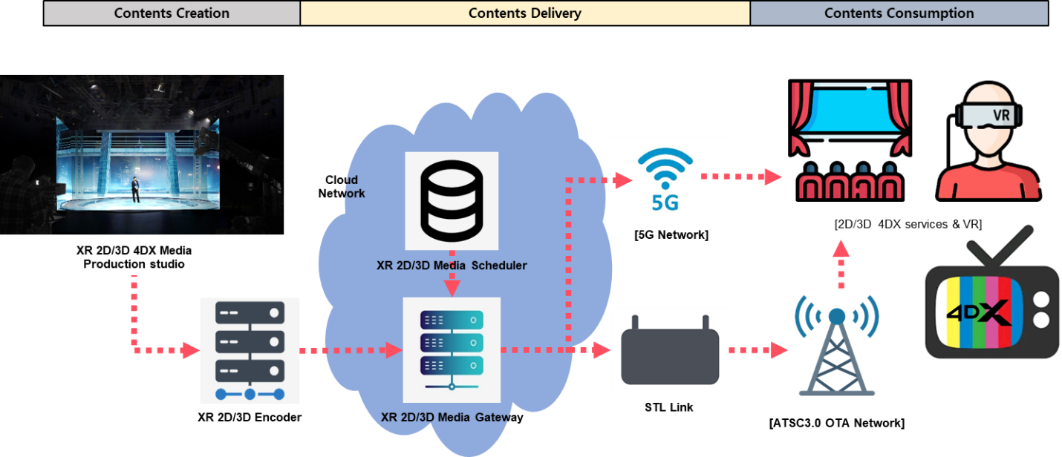
Figure B.1 Example of UHD-VVC 3D Service Scenario.
Figure B.1 shows the service scenario of an immersive stereoscopic media service. It could support services based on large screens and personal screens such as Cinematic LED, 8K-TV and HMD (Head-Mount Display).
- Over-the-Air (OTA)
In the case of UHD and HD simulcast mode, the left view and the right view of a stereoscopic 3D video component can be a UHD video and an HD video, respectively. It can be transmitted as over-the-air as shown in the example configuration of Figure B.2. There is no dependency between the two views as the two views are coded independently. Each view can be delivered via separate PLPs (it can be differentiated according to ATSC 3.0 physical layer multiplexing schemes) and decoded independently. That is, an ATSC 3.0 mobile receiver acquires HD right-view video data from a PLP and offers a mobile HD service. An ATSC 3.0 fixed receiver acquires UHD video data from a different PLP and provides a UHD service. Moreover, when a receiver can get data from the two PLPs in ATSC 3.0 physical layer frames, the receiver acquires a UHD left view and an HD right view video simultaneously. It provides a 3D service by combining two views.
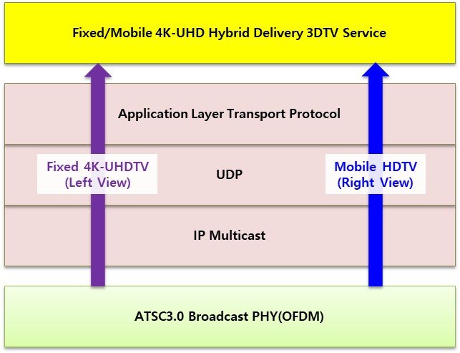
Figure B.2 ATSC3.0 VVC-3D OTA Service Delivery.
By using layered coding (i.e., Multilayer VVC) service mode, the HD view can be coded in a base layer and the UHD view can be coded through both base and enhancement layers. Figure B.3 describes an example configuration for the fixed/mobile hybrid 3DTV service by using Multilayer VVC (256-QAM, QPSK & 16-QAM are just an example.). Each layer can be delivered via the single or separate PLPs. If a separate PLP scheme is used, the base layer can be delivered via a PLP for mobile service and the enhancement layer can be delivered via a different PLP. Thus, two PLPs, a more-robust one for a base layer and a less-robust higher-bandwidth one for an enhancement layer can be used for this Multilayer VVC-based approach. That is, a mobile receiver acquires HD right-view video data from an ATSC 3.0 physical layer frame and offers a mobile HD service. Moreover, a fixed receiver needs to acquire the UHD view by using both the base and the enhancement layers from two different PLPs. The receiver displays 3D service by combining two views.
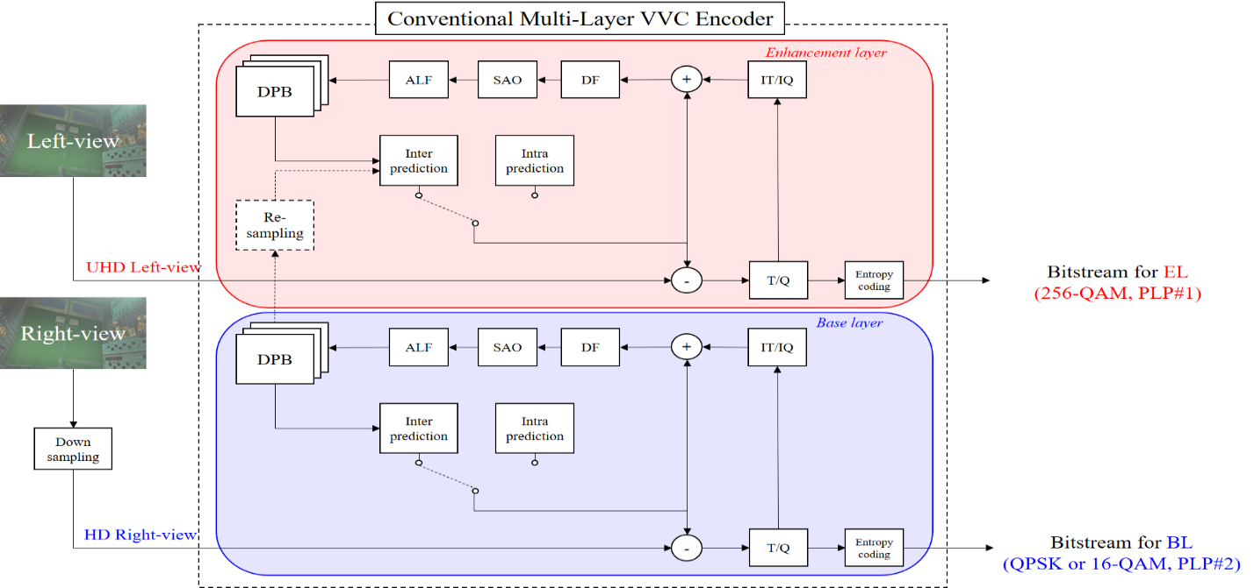
Figure B.3 Example configuration of a mobile HD right view and a fixed UHD left view using Multilayer VVC.
- Over-the-Top (OTT)
In the case of OTT IP streaming service, the 3D image process is similar to Figure B.3. Figure B.4 describes an example configuration for IP streaming service delivery by using Multilayer VVC. both base and enhancement layers encoded using Multilayer VVC. Services are provided over a single IP and HTTP protocol based on layered coding.
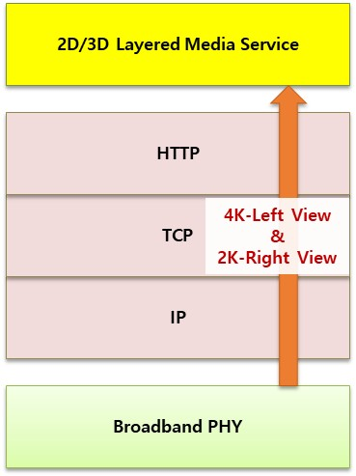
Figure B.4 ATSC 3.0 VVC-3D Broadband (OTT) Service Delivery.
- HMD Application
In case of HMD application service, the 3D image process is similar to Figure B.3. Figure B.5 describes an example configuration for HMD service by using Multilayer VVC.
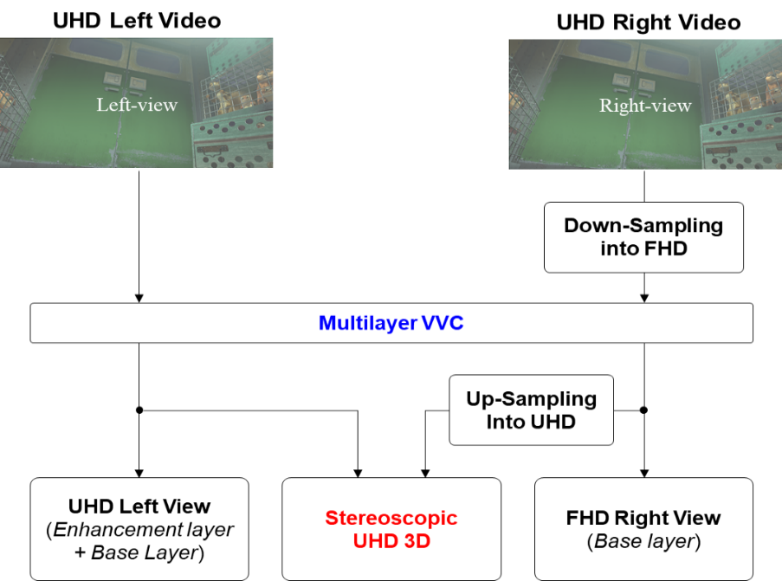
Figure B.5 Example configuration of HMD using Multilayer VVC.
- Video Enhancement Information
Video Enhancement Information (VEI), as described in ATSC A/104 [10], should be included in the stream when the spatial resolutions of the Reference View and Additional View are different. For example, if the spatial resolution differs by not less than 4 times When the spatial resolution differs by not less than 4 times scalability ratio (ex. Left Image 8K, Right Image 2K), VEI could help 3D picture quality significantly improved, when the difference of resolutions between two views is too large.
– End of Document –

The term ‘access unit’ is defined by the HEVC standard [13].
Multilayer VVC corresponds to the Multilayer Main 10 profile and Multilayer Main 10 4:4:4 profile defined by the VVC standard.

